Name: Nara Cheyklin ID: 6538097021
- Screenshot of ros2 interface show ros2_text_encoder/srv/TextEncode
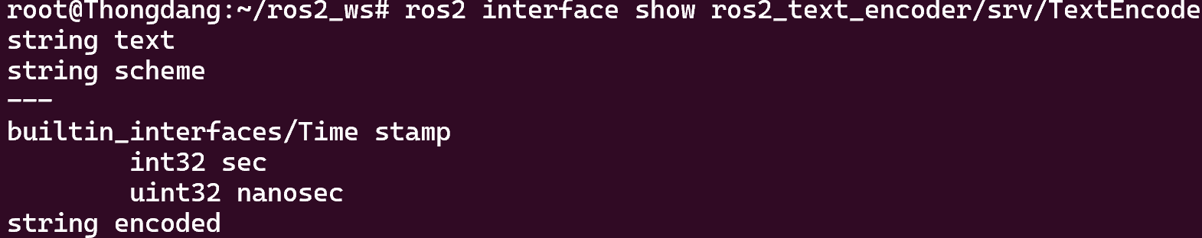
- Screenshot of ros2 node info <node_name>
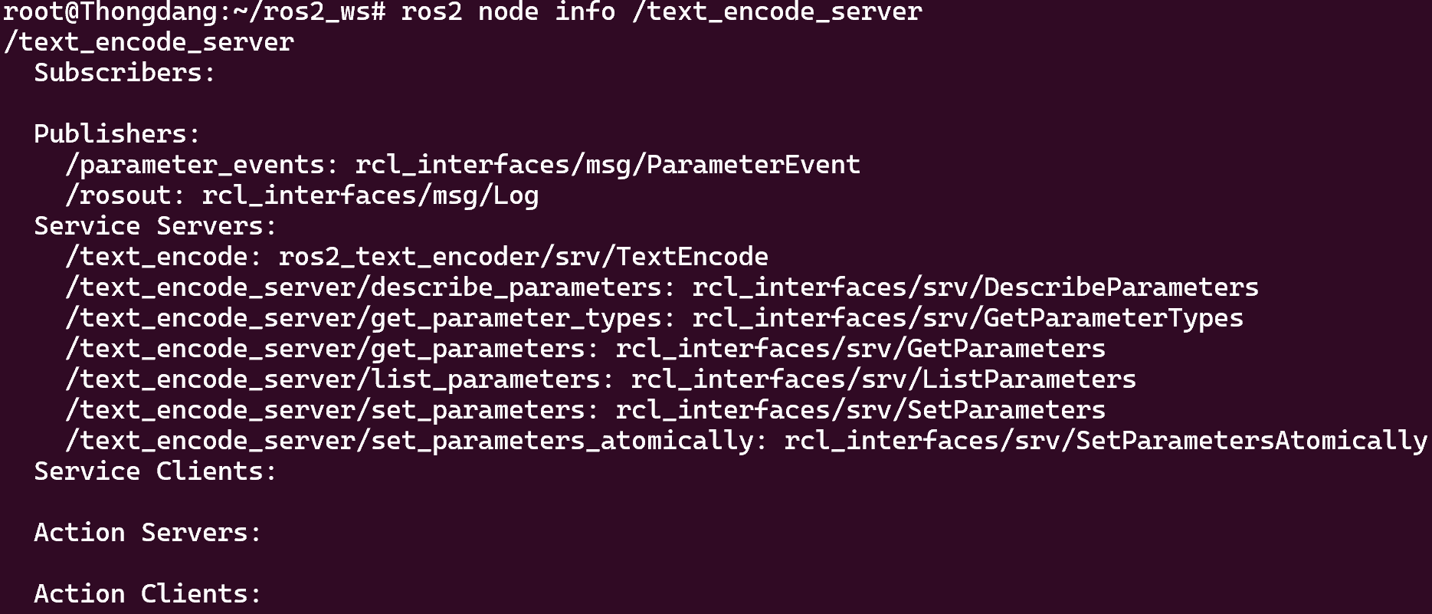
- Screenshot of service call result (showing encoded output)

- Sourcecode:
4.1 ) text_encode_server.py
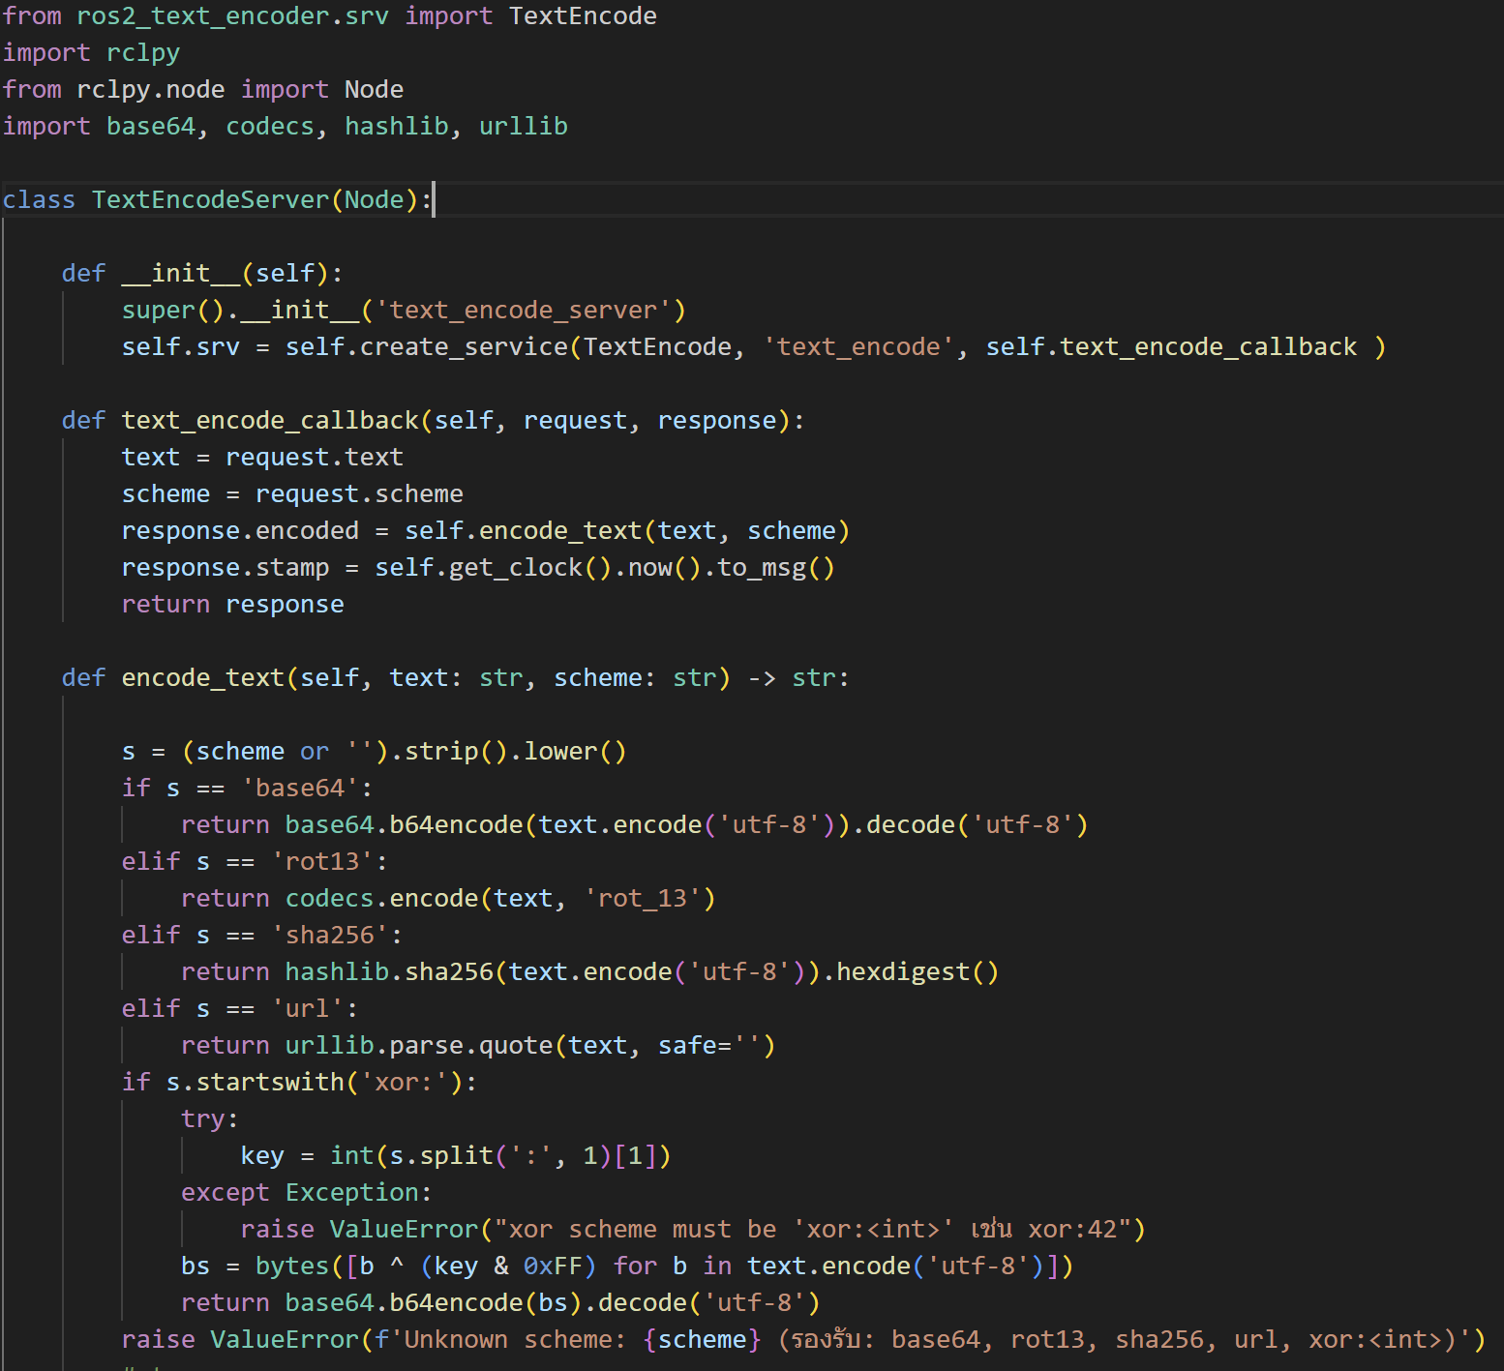
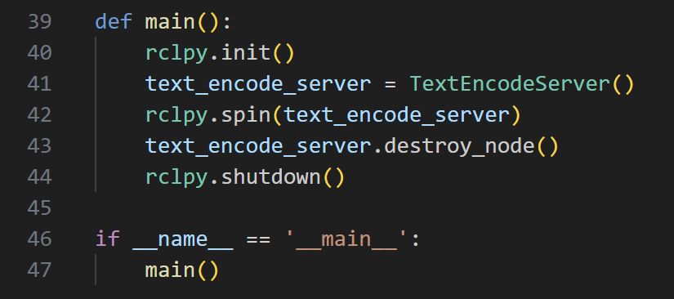

4.2) turtle_sub.py
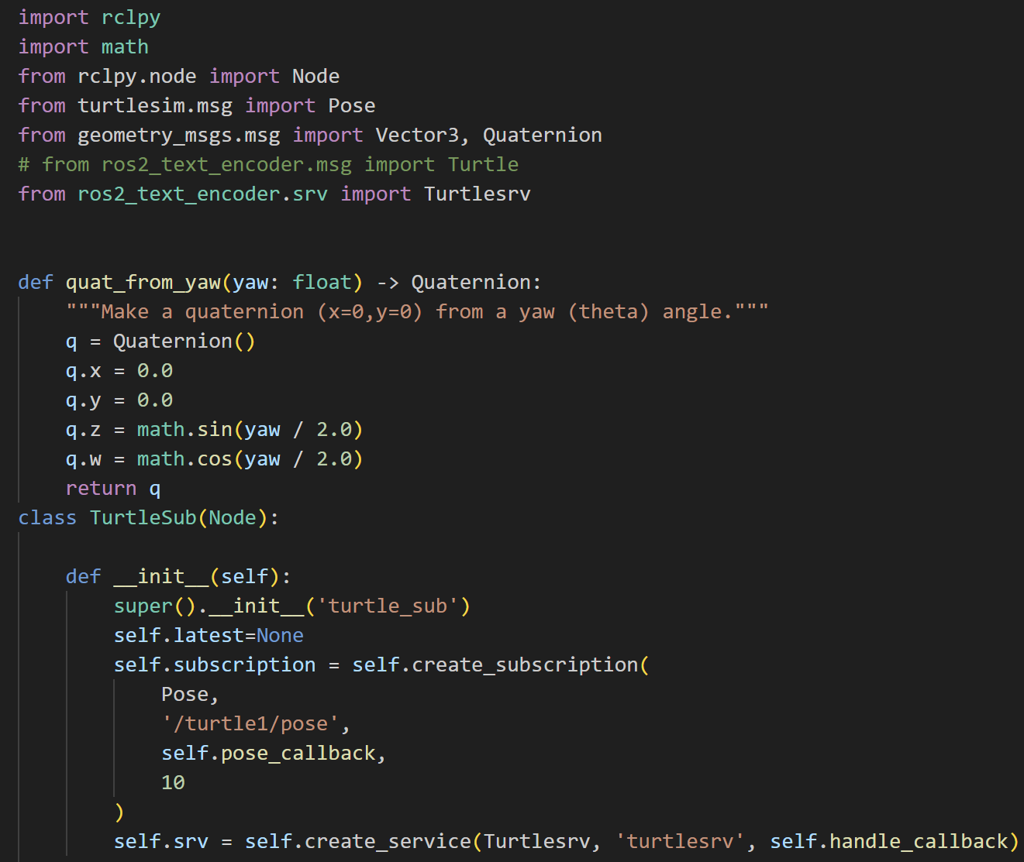
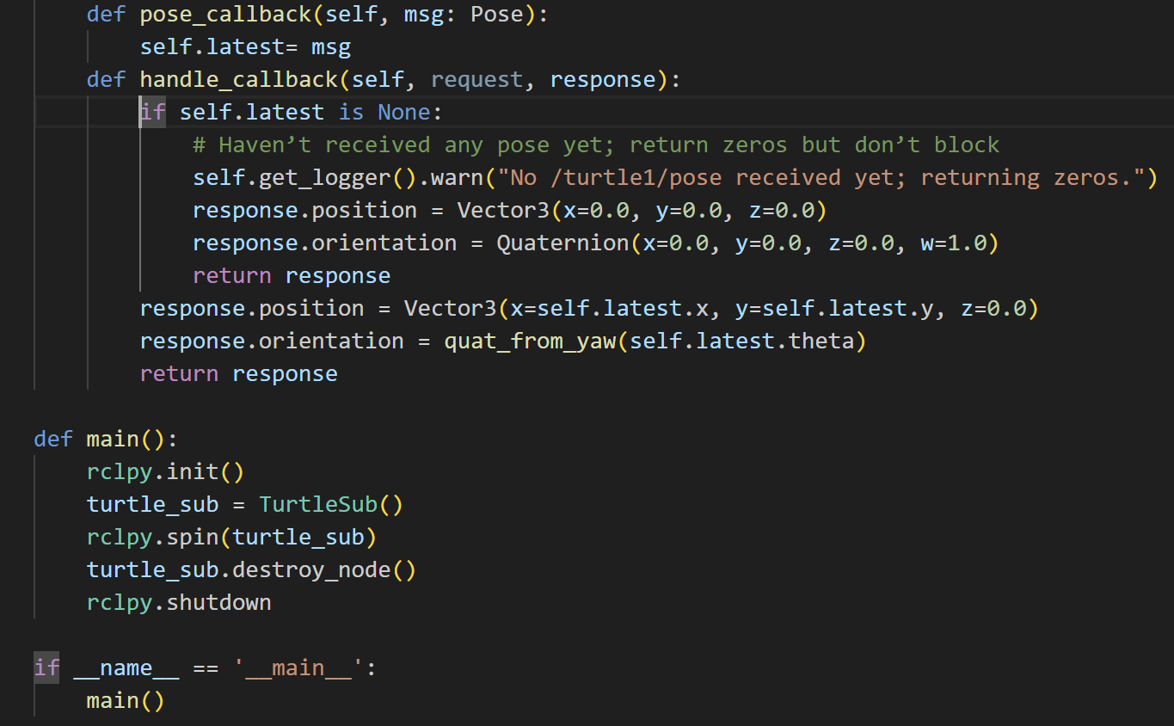
Command:
1.
2.

3. Service call twice: first time at the spawn point, secound time after a movement with turtle_teleop_key
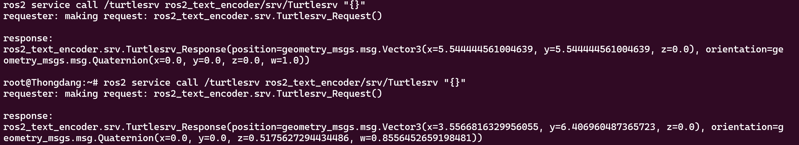
Turtle Final Position
